Ukpik-1

*Communication Subsystem*

REVISION NUMBER: *0.1*

DATE: *2020-10-02*

COMPILED BY: *Nicholas Mitchell*

CONTRIBUTIONS FROM: *Nicholas Mitchell*

**Document Change Record**

|  |  |  |  |
| --- | --- | --- | --- |
| Issue | Date | Changes Made | Name |
| 0.1 | 2020-10-02 | First Draft | Mitchell, Nicholas |
|  |  |  |  |
|  |  |  |  |

**Reference Documents**

*Insert applicable reference document titles, such as requirements documents*

**Terms, Definitions, Abbreviations**

|  |  |
| --- | --- |
| CSA | Canadian Space Agency |
|  |  |
|  |  |
|  |  |
|  |  |

Contents

Requirements 1

Architecture and Interface Diagrams 1

Functional Operations 1

Ground Station and Operations 1

Design and Status 1

Payload Data Plan 1

Operation Organization 2

RF Licensing Status 2

Link Budgeting and Protocols 2

Antenna design 2

Assembly and Integration Plan 2

Test and Verification Plan 2

Schedule and Work Plan for Phase C2 and D 3

Datasheets for COTS Components 3

# Requirements

|  |  |  |
| --- | --- | --- |
| COMMs Requirements |  |  |
| Requirement # | Requirement | Parent Req ID |
| COM-01 | The CubeSat shall be able to communicate with ground stations | SY-GR07 |
| COM-02 | The CubeSat shall downlink [5] minimum pictures to ground | SY-PA04 |
| COM-03 | The CubeSat shall receive commands | SY-GR08, SY-SS08 |
| COM-04 | The CubeSat shall downlink telemetry | SY-GR09, SY-SS09 |
| COM-05 | The CubeSat shall be able to receive data and talk to ground station | SY-GR08 |
| COM-06 | The CubeSat must adhere to licensing restrictions |  |
| COM-07 | The CubeSat must not deploy the antenna within the first 30 minutes of deployment | SY-SS31 |
| COM-08 | The CubeSat shall communicate via the AX.25 protocol |  |
| COM-09 | The CubeSat shall turn off transmitter upon request from Grounstation |  |
| COM-10 | The mission design must comply with CCSDS telecommunication standards as outlined in [AD##] (TBD) | SYS-COM-010 |
| COM-11 | All necessary RF communications licenses must be obtained prior to launch | SYS-COM-011 |
| COM-12 | The CubeSat must be fitted with devices to ensure immediate cessation of its radio emissions by command whenever such a cessation is required, in accordance with the provisions of the ITU Radio Regulations [AD7] | SYS-COM-012 |
| COM-13 | A communications link with the satellite must be established when it is at least ## degrees (TBD) above the horizon from the ground segment | SYS-COM-020 |
| COM-14 | The CubeSat must be able to receive and execute real-time commands from the ground at all times when the satellite is within view of an operating ground station and at least 5 degrees above the horizon | SYS-COM-021 |
| COM-15 | Command data must be uplinked to the spacecraft in S-band Earth Exploration Satellite Service | SYS-COM-030 |
| COM-16 | The CubeSat satellite must be protected against incomplete or incorrect transmission of commands | SYS-COM-031 |
| COM-17 | An ineffective, non-operating command must exist to test the communication link | SYS-COM-032 |
| COM-18 | The command function must support time-tagged commands sufficient to cover a minimum of three days of autonomous operation | SYS-COM-033 |
| COM-19 | Science and telemetry data must be downlinked by the spacecraft in S-band Earth Exploration Satellite Service | SYS-COM-040 |
| COM-20 | The maximum bit error rate during data downlink must be better than 10^(-5) | SYS-COM-050 |
| COM-21 | The telecommunication system must be capable of simultaneously handling telemetry and science data downlinking and uplinked commands i.e. full duplex (TBC) | SYS-COM-060 |
| COM-22 | The telecommunication equipment must support the linkage needs of the demo payload as specified in [AD##]. (TBD) | SYS-COM-070 |
| COM-23 | The CubeSat must have sufficient communications systems to transfer data from the demo payload back to Earth | SYS-COM-090 |
| COM-24 | The communications subsystem must draw less than 6 W during transmission to the ground (TBC) | SYS-COM-110 |
| COM-25 | The communications subsystem must have mass no more than 500 g (TBC) including antenna | SYS-COM-120 |
| COM-26 | The communications subsystem must have at least one RF inhibit (TBC) | SYS-COM-130 |
| COM-27 | The communications subsystem must produce RF power output of no greater than 31.8 dBm (TBC) at the transmitting antenna | SYS-COM-140 |
| COM-28 | The communications subsystem must provide a reliable link to the ground station of at least 3 dB margin under nominal contact geometry of a ## degree (TBD) elevation angle. | SYS-COM-150 |
| COM-29 | The communications subsystem downlink frequency range must be 2200 – 2290 MHz (TBC) according to the Canadian Frequency Allocation Table | SYS-COM-170 |
| COM-30 | The communications subsystem uplink frequency range must be 2025 – 2110 MHz (TBC) according to the Canadian Frequency Allocation Table | SYS-COM-180 |
| COM-31 | The communications subsystem must use one of the recommended modulation schemes as per CCSDS 401.0-B-29 [AD8] | SYS-COM-190 |
| COM-32 | The communications subsystem downlink transmission rate must be at least 250 kbps (TBC) | SYS-COM-200 |
| COM-33 | The communications subsystem uplink transmission rate must be at least 120 kbps (TBC) | SYS-COM-210 |
| COM-34 | The XYZ communications subsystem must use Two Line Element values for orbit propagation in order to define RF link periods | SYS-COM-220 |
| COM-35 | The XYZ satellite must provide command channel (uplink) authentication to ensure that only authorized mission control centers have access to the space segment | SYS-COM-230 |
| COM-36 | The communications system must utilize ## (TBD) –hand polarization for uplink and ## (TBD) –hand polarization for downlink | SYS-COM-240 |
| COM-37 | All intentional receivers must be designed to minimize their susceptibility to out-of- band RF signals found in the surrounding environment, including emissions from the on- board transmitters | SYS-COM-250 |
| COM-38 | All intentional receivers must be designed to withstand 160 dBμV/m at any frequency below 40 GHz at the receiving antenna (TBC), without permanent degradation to performance, reliability or life | SYS-COM-251 |
| COM-39 | All intentional receivers must be designed to operate without degradation in the presence of ground, sea, and space-based radars as defined in [RD3] | SYS-COM-252 |
|  |  |  |
|  |  |  |
|  |  |  |
|  |  |  |
|  |  |  |
|  |  |  |
|  |  |  |

# Architecture and Interface Diagrams

Note that all impedances are 50 ohms unless otherwise specified.

Functional Block Diagram Endurosat Type II Transceiver

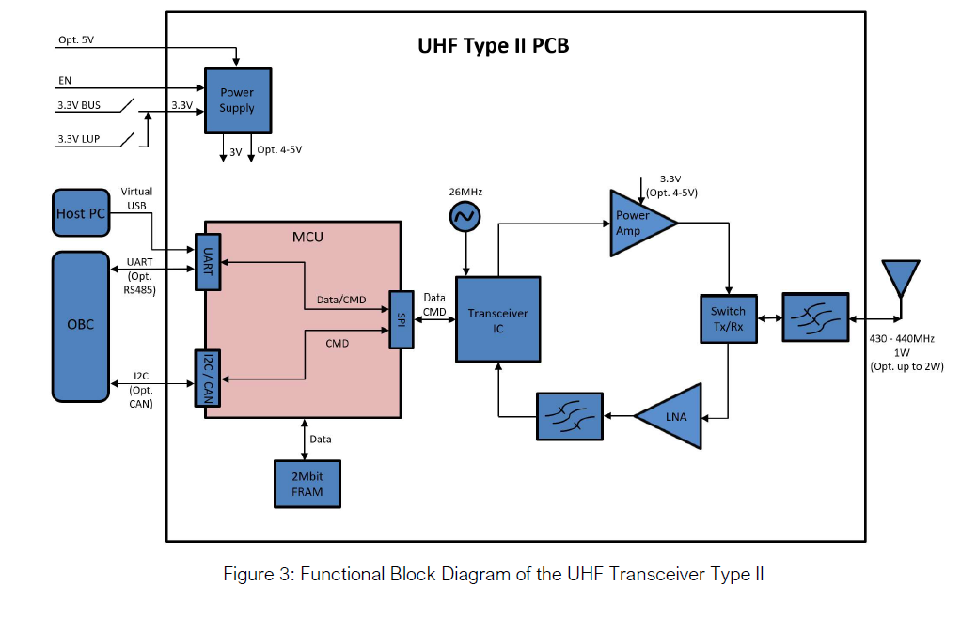

Connector: MMCX to antenna

Antenna Block Diagram:

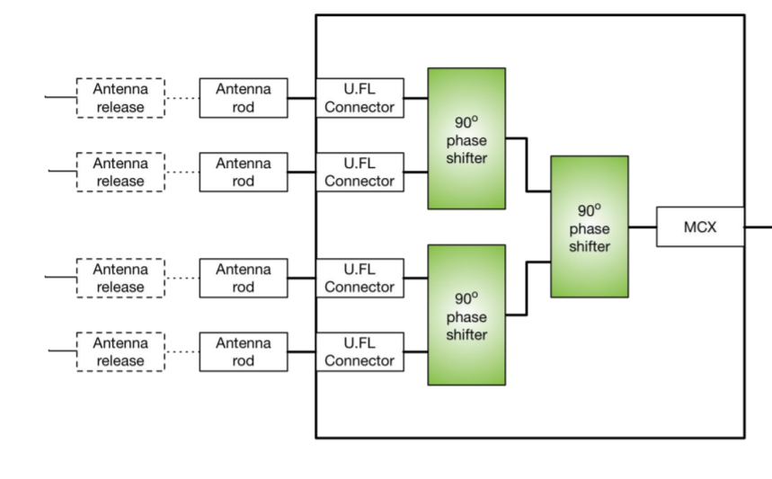

Note that antenna release mechanism is not included inside the antenna purchase.



# Functional Operations

Power Supply Diagram:

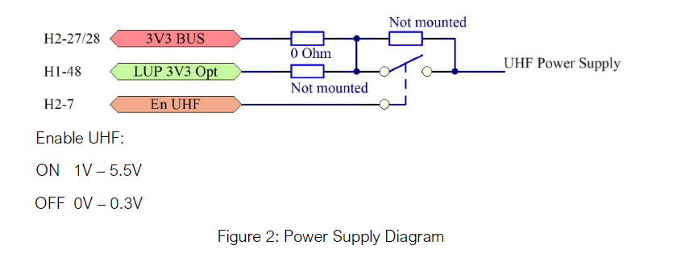

H2-7 is the enable pin which can be controlled by the OBC. The enable pin will cut off power in the case that the transceiver must be shut down.

# Data Transfer Modes Designed:

1. Downlink Telemetry and Housekeeping data
   1. Instantaneous Housekeeping data
   2. List files on Cubesat
   3. Downlink telemetry and housekeeping data from x time.
2. Downlink Images
   1. Send image thumbnails
   2. send specific image
3. Schedule Image Capture
   1. Capture image(s) with at x time.
4. Onboard Computing Update Command
   1. Can include system image or select files on Cubesat.
5. Stop all communications (IARU requirement as well)
6. Uplink Telecommands
   1. Reformat SD card
   2. Update TLE values
   3. Delete file(s)
   4. Reboot system
   5. Schedule rotation of Cubesat for power generation purposes.

# Frame Description:

## Start I-Frame:

* Ground station transmits to satellite to Start Information Sending Frame that sets up parameters such as:
  + Command for current transmission
  + Maximum end transmission time
  + Next time to transmit

## TT&C I-Frame:

* Frame transmitted by satellite containing Telemetry, Tracking, and Command data

Contains the following sensor information:

* OBC time
* Battery voltages and currents
* Temperature Sensors
* Solar Panel voltages + currents
* Magnetorquer current/volt
* Magnetic compass sensor
* Gyroscope data
* Uptime between last update to the epoch
* Antenna deployment currents
* Payload health information (tbd)
* Etc…

## Acknowledge S-Frame (ARQ)

* Supervisory frame used to transmit from the ground station to the satellite to acknowledge frames received and to request next action to be conducted

4 possible actions:

* Acknowledge send next frame
* Acknowledge do not send next frame
* Selective Reject a frame for retransmission
* Reject all frames, retransmit all

## VR camera I-Frame

* Information frame transmitting images from the satellite

2 modes to send images in varying qualities:

* Primary mode to send back 12-bit JPEG images at 3000x3000 pixels per image at 13.5MB
* Secondary mode sends back images with up to 15x compression <1MB per image using lower bit depth

## OBC (Onboard Computing) Update I-Frame

* Information frame transmitting from ground station up to satellite to update or patch onboard computer flight software

## End Transmission S-Frame:

There will be 2 types of end transmission S-Frames:

1. Supervisory frame used to transmit to the Satellite to end transmission at the end of the current command.
2. Supervisory frame used to transmit to the Satellite to end transmission at the end of a transmission period. This happens when the satellite is no longer in communication range of the groundstation.

# Downlink Image Command:

## Diagram:

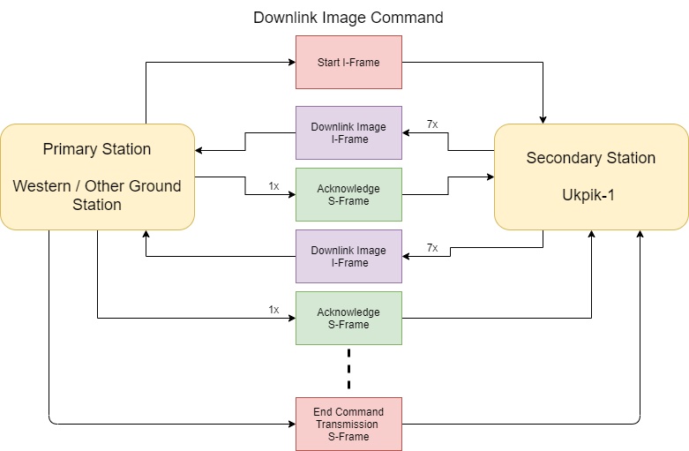

## Description:

1. 1x Start I-Frame transmitted from ground station to begin a communication sequence with an image transmission command (other functionalities work in similar manor)
2. 7x Camera downlink image I-Frames w from satellite to collect payload camera data.
3. 1x acknowledge S-Frame transmitted from ground station to acknowledge received info and decide what next action is based on the 4 possible actions provided in [HERE](#_Acknowledge_S-Frame_(ARQ))
4. Continue with steps 2 and 3 until done with command or time to transmit runs out.
5. 1x End Command Transmission S-Frame that will end the current command sequence.

# OBC Update Command:

## Diagram:

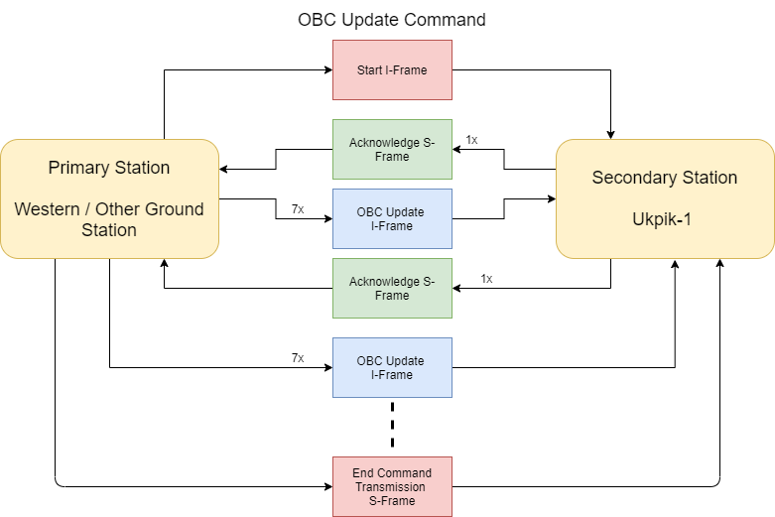

## Description:

1. 1x Start I-Frame transmitted from ground station to begin a communication sequence with OBC patch command
2. 1x acknowledge S-Frame transmitted from satellite to acknowledge received info and decide what next action is based on the 4 possible actions provided in [HERE](#_Acknowledge_S-Frame_(ARQ))
3. 7x OBC Update I-Frames transmitted by ground station to the satellite to provide data for OBC Patch
4. Continue with steps 2 and 3 until done with command or time to transmit runs out.
5. 1x End Command Transmission S-Frame that will end the current command sequence.

# Image Acquisition Command:

## Diagram:

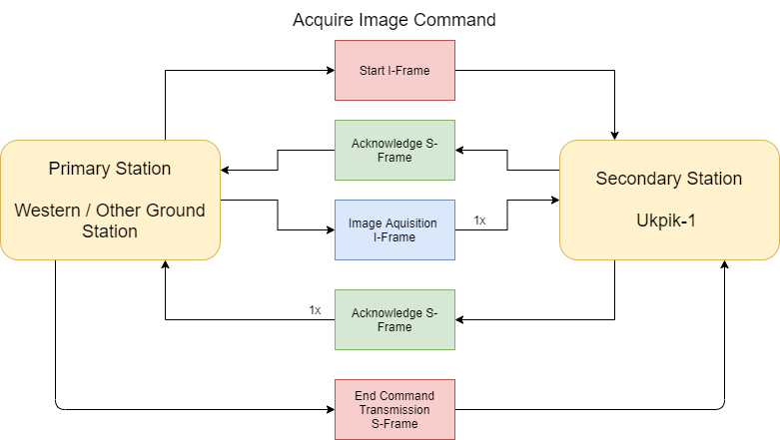

## Description:

1. 1x Start I-Frame transmitted from ground station to begin a communication sequence with Acquire Image command
2. 1x acknowledge S-Frame transmitted from satellite to acknowledge received info and decide what next action is based on the 4 possible actions provided in [HERE](#_Acknowledge_S-Frame_(ARQ))
3. 1x Image acquisition frame which will detail the next time to image.
4. 1x acknowledge S-Frame transmitted from satellite to acknowledge received info and decide what next action is based on the 4 possible actions provided in [HERE](#_Acknowledge_S-Frame_(ARQ))
5. 1x End Command Transmission S-Frame that will end the current command sequence.

# Telemetry and Housekeeping Data Command:

## Diagram:

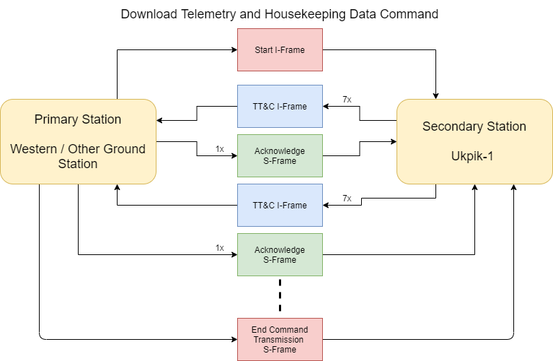

## Description:

1. 1x Start I-Frame transmitted from ground station to begin a communication sequence with a telemetry and tracking transmission command (other functionalities work in similar manor)
2. 7x TT&C I-Frames transmitted from satellite to collect housekeeping data.
3. 1x acknowledge S-Frame transmitted from ground station to acknowledge received info and decide what next action is based on the 4 possible actions provided in [HERE](#_Acknowledge_S-Frame_(ARQ))
4. Continue with steps 2 and 3 until done with command or time to transmit runs out.
5. 1x End Command Transmission S-Frame that will end the current command sequence.

# Stop Communication Command:

## Diagram:

## Description:

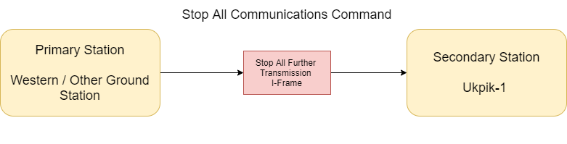

1. 1x Start I-Frame transmitted from ground station to send Stop Communication command

**WILL PERMENANTLY CEASE TRANSMISSION ABILITIES**

# Ground Station and Operations

## Design and Status

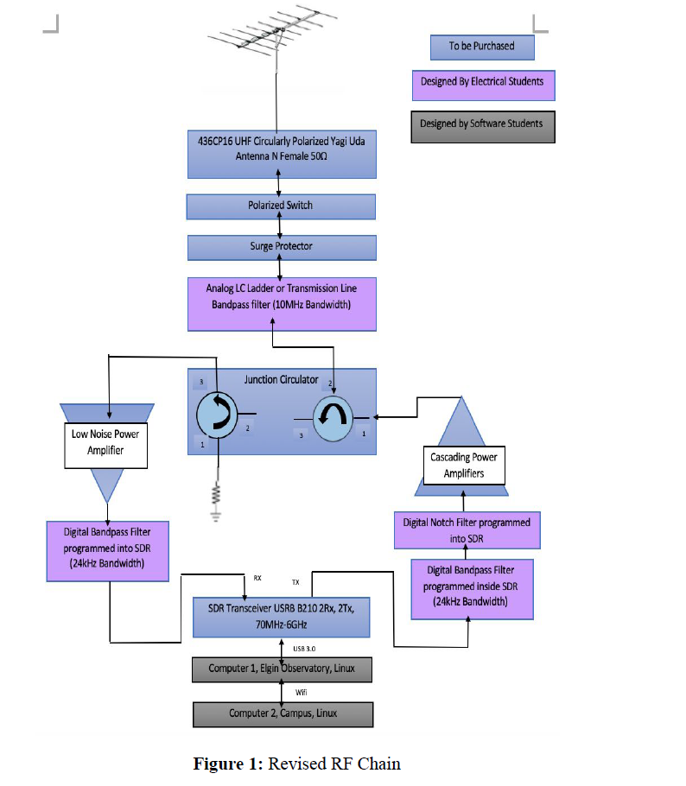

*The current design status of the groundstation is that the components have been mostly selected except for the specific power amplifier on the transmit side. The specification that needs to be fit for the power amplifier is that it must achieve a gain of 44.25 dB in order to emit a 1W signal if the SDR is operating at -40 dBm.*

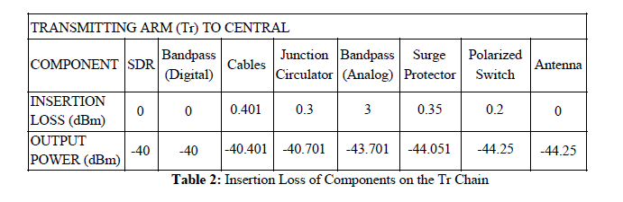

*Otherwise the groundstation has been priced out and the components have been selected. The next stage would be to purchase the components that fit as well as start working on an S Band receiver for the groundstation. The S band structure will be designed next for the system.*

## Payload Data Plan

*Provide a step-by-step walkthrough of how the data will be received, stored, curated, and distributed*

Don’t know if this is inside the scope of Comms, this is more the groundstation software I believe?

## Ground Station Access Time Analysis

Taken from the Orbital Team analysis Powerpoint:

## 

## Operation Organization

## RF Licensing Status

Current status of the licensing is:

1. We have contacted our local RAC organisation, and they are aware of our mission.
2. We have completed and sent the first IARU application. We are Currently Waiting on Dr. Jayshri Sabarinathan to get her Advanced amateur radio license and apply for the callsign.
3. Dr. Jayshri Sabarinathan has already obtained the basic amateur license.

# Link Budgeting and Protocols

Link to the most recent link budget: All protocols and assumption are made in comments or in text.

<https://github.com/cubesat-project/CubeSat/tree/master/Ground%20Segment/COMMS%20--%20GS%202019/Link%20Budget>

# Antenna design

The antenna is a COTS component that we purchase. Please see below for the link to the datasheet.

<https://gomspace.com/shop/subsystems/communication-systems/nanocom-ant430.aspx>

# Assembly and Integration Plan

# Test and Verification Plan

|  |  |  |
| --- | --- | --- |
| **Requirement ID** | **Verification Strategy** | **Resources** |
|  |  |  |
|  |  |  |
|  |  |  |
|  |  |  |
|  |  |  |
|  |  |  |
|  |  |  |

# Schedule and Work Plan for Phase C2 and D

|  |  |  |
| --- | --- | --- |
| **Task Description** | **Estimation of Time and Human Resources** | **Required Resources to Complete** |
|  |  |  |
|  |  |  |
|  |  |  |
|  |  |  |
|  |  |  |
|  |  |  |
|  |  |  |

# Datasheets for COTS Components

*Datasheet for MCX and MMCX connectors:* [*https://literature.hubersuhner.com/Technologies/Radiofrequency/RFConnectorsEN/?page=118*](https://literature.hubersuhner.com/Technologies/Radiofrequency/RFConnectorsEN/?page=118)

*Datasheet for Coax Cable:*

*Not yet chosen.*

*Datasheet for Transceiver + Antenna:*

[*https://github.com/cubesat-project/CubeSat/tree/master/Space%20Segment/COMM/COMM%20--%20NickSummer2019/CubeSat*](https://github.com/cubesat-project/CubeSat/tree/master/Space%20Segment/COMM/COMM%20--%20NickSummer2019/CubeSat)

*Datasheet for all groundstation components:*

[*https://github.com/cubesat-project/CubeSat/tree/master/Ground%20Segment/COMMS%20--%20GS%202019/Link%20Budget/Equipment*](https://github.com/cubesat-project/CubeSat/tree/master/Ground%20Segment/COMMS%20--%20GS%202019/Link%20Budget/Equipment)